Credit One Analysis

By Robert Provost

Although, we cannot ensure or guarantee customer payment, due to people having a free will to make their own choices. We would need to approve customers that are more likely to pay. The current Credit One model for approving credit, has a Default rate of approximately 28%. This means that out of every 4 credit approvals there is 1 customer that will default. Although it is reasonable, this is not acceptable to Credit One clients.

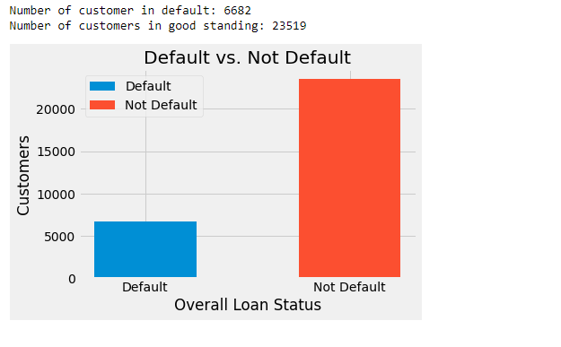

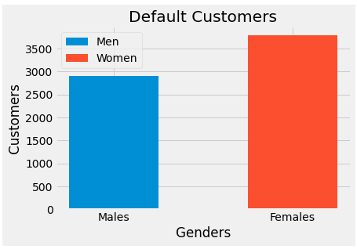

After an extensive data analysis, which involved splitting the default variable into Default/Not Default datasets, and visualizing the relationships of variables within the datasets, and then visually comparing those dataset/variable combinations. My conclusions where clear that demographics, payment status, payment history were the key features to solving this problem.
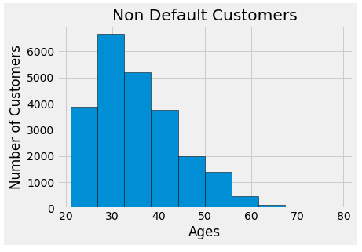
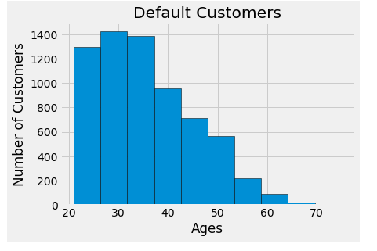

My approach to finding the best fitting model that would improve the not default/default ratio, would be to test models with demographics first. Demographics are equal to who the person may be, and possible personality traits that may be hidden until you combine the variables.

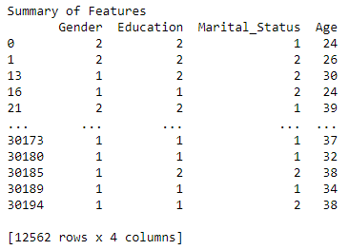

The next set of variables to consider as important would be the payment status. This variable is the most likely to predict if a customer will pay, and most importantly, pay on time. This variable would have false negatives without the demographics. Just the combination of these two variable sets started to show a promising model.

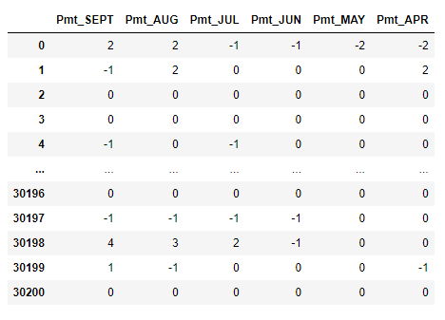

The next set of variables were considered for tweaking the payment status, by fitting in the amounts paid previously, it makes the model slightly tighter.

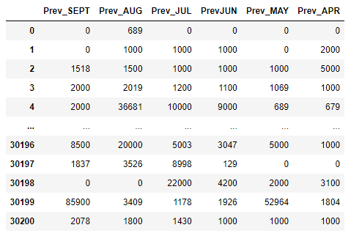

The remaining variables of the original dataset made false positives/negatives increase.

The result of my EDA and model testing, that a model is possible, for every 6 customers there will be 1 default customer. This equates to an 18% default rate. This model has a lower amount of False Positives (not default) customers compared to the original model. But it has False Negative (default) rates that are not preferable in a model. This model has the lowest possible error rates for the given dataset.

Gradient Boosting Classifier

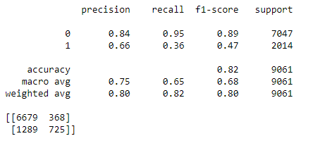

In essence, it comes down to choosing the lesser of two evils. This model will give a lower default rate with some credit worthy customers not receiving approval, which is lost potential revenue, vs the current model which is going to lose clients.
My notebook is located at my github repository below:

https://github.com/n1ovu/Credit_One

